Memorial Gallery Service Wall of Honor Form
The entrance to the building will feature a Memorial Area. We will be memorializing, remembering, and honoring anyone who has served that you would like to recognize. We are making available 6.5"x2.5" memorial plaques to be placed on the wall naming your loved one. The plaques will be a one time charge and remain on the wall as long as the building stands. You may order multiple plaques. If you are ordering more than one plaque add each plaque to cart individually to explain each inscription customization.
The plaques will be a three line memorial where you place the service members name on line one and a branch of service or message on line two.
You can purchase as many plaques as individuals you wish to honor and the Wall of Honor and Remembrance will display it for all to see.
There will be separate sections of the wall to honor military veterans, police officers, fire, and EMS responders.
Please Provide Your Contact Information
First & Last Name: _________________________________________________________________
Email: _________________________________________________________________
Address: _________________________________________________________________
Phone Number: _________________________________________________________________
Examples of Memorial Design
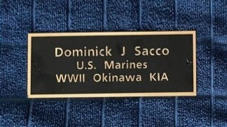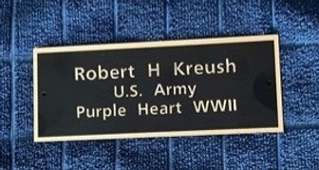
Provide up to three lines of text for the Memorial Plaque(s): Add additional plaques on reverse
___________________ ____ _________________ ___________________ ___________ __________
___________________ ____ _________________ ___________________ ___________ __________
___________________ ____ _________________ ___________________ ___________ __________
Please make your check payable to: “Town of Trumbull” with note: TVFRC Donation
Mail this form and check to: Trumbull VFRC, P.O. Box 110657, 50 Quality Street, Trumbull, CT 06611
For questions, comments, or concerns please contact: Dan Sacco at (203) 858-6371 dansacco@me.com

